Name: Priyadharshini Stalin

Hardening Linux

**1.Keep Your System Updated**:

**2.Enable a Firewall**:

Configure a firewall to restrict incoming and outgoing network traffic.

**Firewall status of safer machine:**

**Turn off (remove) all unneeded services (e.g., ssh, http, ftp, etc.**

let’s us selectively delete rules we want removed

safer@safer:~$ sudo ufw delete 4

**After deleting.**

* try to ssh in from client as your test user "testuser" many w/o giving a password and see what happens.

I have created testuser in safer machine and tried logging in from client1 without entering password.

**3. Secure SSH Access**

SSH keys are a powerful and secure authentication method that offers numerous advantages over traditional password-based authentication. They provide a strong, automated, and scalable solution for securing remote access and data transfers while simplifying user management and improving overall system security.

***I have created ssh keys in client1 machine and copied to safer machine and safer machine contains the authorized keys.***

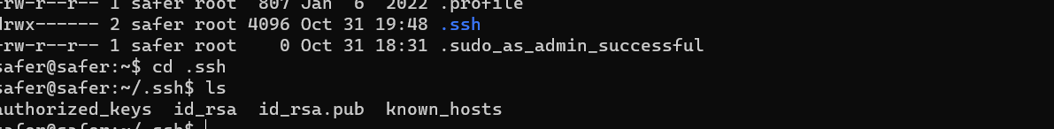

Now I tried to do ssh from client1 to safer machine, it didn’t prompt for password.



4.Enabling a whitelist

Enabling a whitelist for a host typically refers to a security practice where you specify a list of approved or trusted IP addresses or domains that are allowed to access a particular service, server, or network

After changing allow and deny config in safer machine, ssh is working from leap machine but not working from client1 machine.

Output from client1 machine



Output from leap machine

